 |  |  | CBD
 |  | CONVENTION ON  BIOLOGICAL DIVERSITY |  |  | Distr.  GENERAL  UNEP/CBD/WG8J/4/INF/17  8 December 2005  ENGLISH ONLY
AD HOC OPEN-ENDED INTER-SESSIONAL WORKING GROUP ON ARTICLE 8(j) AND RELATED PROVISIONS OF THE CONVENTION ON BIOLOGICAL DIVERSITY
Fourth meeting
Granada, Spain, 23-27 January 2006
Item 10 of the provisional agenda*

SUBMISSION TO THE CONVENTION ON BIOLOGICAL DIVERSITY ON ADVICE ON THE REPORT OF THE AD HOC TECHNICAL EXPERT GROUP ON GENETIC USE RESTRICTION TECHNOLOGIES

Note by the Executive Secretary

The Executive Secretary is circulating herewith, for the information of participants in the fourth meeting of the Ad Hoc Open-ended International Working Group on Article 8(j) and Related Provisions, a submission from EcoNexus and the Federation of German Scientists to the Convention on Biological Diversity on “Advice on the report of the Ad Hoc Technical Expert Group on Genetic Use Restriction Technologies"
The report is being circulated in the form and language in which it was received by the Secretariat.

Submission to the Convention on Biological Diversity on “Advice on the report of the Ad Hoc Technical Expert Group on Genetic Use Restriction Technologies"

From EcoNexus and the Federation of German Scientists.

December, 2005

Mr. Hamdallah Zedan
Executive Secretary of the Convention on Biological Diversity
United Nations Environment Programme
413 St-Jacques Street, 8th floor, Office 800
Montreal, Quebec, Canada, H2Y 1N9

Ref: SCBD/STTM/DCO/va/48601 "Advice on the Report of the Ad Hoc Technical Expert Group on Genetic Use Restriction Technologies"

Table of Contents
V-GURTs (Terminator Technology): Design, Reality and Inherent Risks ………………………………… .3
1. Overview 3
2. Brief description of terminator technology (V-GURTs) 3
3. Designing V-GURTs: the concepts and the molecular components 3
Genes, gene constructs and transgenes 3
General design and concept behind inducible seed sterility 4
Delta & Pine Land design 4
4. Limitations in the V-GURTs design and performance 6
a. Problems arising from the general biological system 6
b. Common transgene problems with particular reference to V-GURTs 7
Gene silencing, including epigenetic changes to DNA and loss of promoter activity 7
Mutations 8
c. GURTs specific problems 8
Leaking promoter systems: 8
Insufficient induction of promoter systems by inducing agent: 8
Unspecific or unintended induction of promoter system: 9
Segregation of the different transgenic components during reproduction: 9
Concluding Summary 9
5. Risk scenarios and potential consequences 9
Scenarios 10
Out-crossing by GM-pollen with activated terminator mechanism (intended design) 10
Out-crossing by GM-pollen with un-activated terminator mechanism 10
Out-crossing by GM-pollen with silenced terminator mechanism 11
Out-crossing by GM-pollen with disabled or segregated terminator mechanism 11
Unintended planting of sterile seeds 11
Out-crossing by GM-pollen or spread of GM-seed with terminator mechanism in a forestry context 12
Concluding Summary 12
6. Final Conclusion and Discussion 12
7. Regarding the Convention on Biological Diversity 14
8. References 14

V-GURTs (Terminator Technology): Design, Reality and Inherent Risks
- Overview
This paper describes in brief the concepts and design behind Terminator technology or Genetic Use Restriction Technology (GURTs) in language accessible to non-scientists. It details the different elements that are theoretically required to assemble gene sequences designed to prevent the germination of seeds.
Having described in brief the way in which the technology is intended to work, the paper then discusses the reality of the technology having to function as part of a biological system, this being the plant, its molecular components and the broader ecosystem, which is inherently changeable and unpredictable. In becoming part of the biological system and its evolutionary processes, the mechanism of GURTs, along with its molecular components, will itself become inherently changeable and unpredictable.
With reference to GURTs, the paper outlines some of the many known problems that can occur in biological systems and details some specific factors that can go wrong with such a complex molecular design and mechanism.
The paper points out that the technology stands in direct conflict with two key defining characteristics of a living organism - its ability to reproduce and its ability to adapt. This latter point, combined with the evolutionary tool of natural selection pressure, raises questions as to whether GURTs can perform reliably or indeed what the consequences would be, were it to fail.
Looking at both scenarios, i.e. for the technology to succeed or to fail, some outcomes can be foreseen, but it must be emphasised that many are unpredictable. However, the potential impacts on agriculture are serious. Reduced levels of germination, unpredictable variability in crop performance, and contamination of crops with GM traits, could ultimately result in food insecurity. This paper concludes that GURTs cannot be used as a predictable or reliable technology. Rather it concludes that the technology of inducible seed sterility is likely to introduce a series of new and, unpredictable problems, with negative implications for biodiversity, agriculture, food security and sustainable livelihoods.

- Brief description of terminator technology (V-GURTs)
Terminator technology, technically known as a Genetic Use Restriction Technology (GURTs), is designed to render seeds sterile at harvest. To this end, plants are genetically engineered with specially designed sequences of genes, that allow for external control over the activation of particular traits (e.g. herbicide tolerance, production of insecticidal compounds, fruit ripening, seed fertility). Such traits can be switched on or off through the application of inducers, such as particular chemicals. In the case of terminator technology, the chemical treatment of seeds prior to their sale to farmers is designed to trigger a genetic process that will allow the plant to grow and to form seeds, but will cause the embryo of each of those seeds to produce a cell toxin that will prevent its germination if replanted after harvest. As this affects the reproduction and viability of a whole crop variety it is technically referred to as varietal-genetic use restriction technology (V-GURTs).
- Designing V-GURTs: the concepts and the molecular components

Genes, gene constructs and transgenes
A gene is, in general, a unit of hereditary information that contains the genetic code for a particular protein. Often this protein will be responsible for a particular trait, such as the colour of flower petals, though many traits are the result of a sequence of interactions between, or contributions from, a larger number of proteins. In its basic design a gene is made up of three components or sections, namely the coding sequence and two regulatory sequences at either end. (see Figure 1)
- A coding sequence: genetic material that contains the information for a particular protein, e.g. an enzyme, a hormone or a structural protein. When the gene is active, this information gets copied (transcribed) into a separate molecule (mRNA) which acts as a template for the cell to make the specific protein.
- A promoter: which acts as a gene switch to turn the gene on or off; this regulatory sequence is located in the front (to the left) of a gene. The promoter determines when and where (in which cell or tissue system) a gene is to be switched on or off.
- A termination sequence: located at the end of a gene. This regulatory sequence contains the signal to stop reading and copying the gene.
A gene construct is an artificial gene composed of, or based on, elements taken from various species, including plant, human, bacteria and virus. So far most of the coding sequences used in commercialised genetically modified (GM) crops originate from bacteria; e.g. the insecticidal Bt endo-toxin gene, the herbicide tolerance genes pat (glufosinate tolerance) and EPSPS (glyphosate tolerance), male sterility (barnase) or indeed most of the genes used in the GURTs systems. The most commonly used promoters in GM crops are variations of the CaMV 35S promoter from a plant virus, and terminal sequences are often derived from bacteria.
A transgene is a gene or gene construct that has been transferred into an organism such as a plant, using genetic engineering techniques, including transformation techniques, i.e. the process of inserting transgenes into the genetic material (DNA) of an organism.

General design and concept behind inducible seed sterility
Propagating future generations of plants from sterile seeds is not possible and so, in order to multiply fertile seeds for sale that will grow into plants that then produce sterile seeds, there must be a mechanism built into the plant that can switch it from producing fertile seed to producing sterile seed. The inducible seed sterility system allows seed companies to produce seed for the market before inducing sterility.
V-GURTs is designed with three main considerations:
- Once sold to farmers, the planted seed should mature to harvest but harvested or out-crossed GM seed should no longer be able to germinate - (trait for seed sterility).
- A seed company must have the ability to multiply GM seed in order to offer it for sale and so fertile seeds are required for reproduction - (blocking of seed sterility trait).
- The seed company must have the ability to switch the sterility trait on before the seed is sold to farmers, e.g. by spraying/treating seeds prior to sale - (inducible system responsive to external treatment with e.g. chemicals).

Delta & Pine Land design
The V-GURTs system examined here is detailed in the patent for “control of plant gene expression” held jointly by the seed company Delta & Pine Land (DPL) and the United States Department of Agriculture (USDA). Its molecular design is detailed in the US patent US-5,723,765, and more recently in the European patent EP-775212B and Canadian patent CA-2196410. (DPL refers to their V-GURTs system as Technology Protection System or “TPS”). Development is said to be at the stage of greenhouse trials. To date no functional V-GURTs system has been reported in the peer reviewed scientific literature.
The basic design of V-GURTs, as outlined in US patent 5,723,765, is composed of 3 gene constructs (Figure 2) which code for:
- a cell toxin or cell-lethal protein that will be produced in the late stage of embryonic development in the setting seed.
The elements of choice are a cell-lethal ribosome inhibitor protein (RIP) and the LEA promoter (late embryogenesis abundant), e.g. from cotton.
For breeding purposes and seed multiplication, the toxin gene is kept inactivated by a spacer (short sequence of DNA) that is placed between the promoter and the coding sequence of the toxin gene. This spacer is framed by a set of short specific DNA sequences that function as recognition sites for a recombinase enzyme. A recombinase acts like molecular scissors; when present, it can cut the DNA strand at the specific recognition sites and thus remove the spacer, thus enabling the activation of the cell toxin gene.
- a recombinase enzyme (molecular scissors) that can activate the toxin gene by removing its spacer. To this purpose the spacer needs to be framed by specific recognition sites.
At present there are four main options for such a site-specific recombination system that could be employed for V-GURTs (see Table 2). The candidate of choice in the DPL design is the Cre/loxP recombination system (derived from bacteriophage P1), with the recombinase CRE being the recombinase enzyme and loxP being the CRE specific recognition sequence placed at either end of the spacer.
During seed multiplication the recombinase gene has to be kept inactive. To this purpose, a promoter that can be blocked (repressed) by specific repressor proteins is placed in front of the gene.
The promoter of choice is an altered CaMV 35S promoter, containing repressor binding sites. As long as the repressor is present and binds to the promoter, the gene will remain switched off.
- a repressor protein that blocks the recombinase gene unless an inducer is applied. To ensure the repressor protein is continuously present, the repressor gene is placed under the control of a strong and constantly active promoter, e.g. CaMV 35S.
The inducible expression system outlined in the DPL patent is the “tetracyclin-inducible system” derived from the bacteria Escherichia coli. This system consists of three parts, namely: the repressor protein (here TetR); repressor specific binding sites in the recombinase promoter (here tet operator sequences); and an inducer that can deactivate the repressor (here the antibiotic tetracycline). In this case, the inducer binds to the repressor resulting in a change of its shape and thus forcing it to detach from the repressible promoter.
DPL recently stated that the tetracycline inducible expression system was no longer their preferred choice. There are other inducible expression systems which would be based on the same principles. Potential inducers include ethanol, hormones, pesticides and metals like copper (Gatz and Lenk, 1998; Wang et al., 2003; Padidam 2003).
As detailed in Figure 2, once the inducer (e.g. tetracycline) has been applied, it will bind to the repressor protein and remove it from the recombinase gene promoter, so that the recombinase enzyme is produced, which in turn will remove the spacer from the toxin gene. This now allows the expression (production) of the toxin in the late embryonic stage of the seed, destroying the embryo and thus preventing the germination of the affected seed.
In theory, this is how V-GURTs works. Variants are designed to using the same principle of “inducible expression systems”.
In summary, V-GURTs is composed of three interdependent expression systems, namely a
- development specific inducible expression system: consisting of a cell lethal toxin gene (e.g. RIP), an embryogenic promoter (e.g. LEA) and a removable blocking spacer.
- inducible site specific recombination system: consisting of a recombinase gene (e.g. CRE), recombinase specific recognition sites framing the spacer (e.g. lox) and an inducible promoter (e.g. CaMV 35S with additional tet operon sequences acting as binding sites for the TetR repressor protein).
- a constitutive expression system (i.e. being continuously active): consisting of a gene coding for a repressor (e.g. TetR) and a constitutive promoter (e.g. CaMV 35S).
An additional component is an external inducer (e.g. tetracycline), that will bind to, and remove, the repressor protein, thereby triggering the GURTs mechanism.
- Limitations in the V-GURTs design and performance
There are a number of design limitations in the DPL version of V-GURTs and in V-GURTs and GURTs in general. Risks arising from these limitations will be discussed in the next section.
Out-crossing is possible in the 1st generation: The most obvious drawback in the design is that V-GURTs plants produce GM pollen capable of fertilising neighbouring crops and related wild and weed plants. Transgenes contained in the GM pollen and (potentially) any proteins expressed by these genes will thus be present in cross-pollinated seed, irrespective of whether this seed has been rendered sterile.
Operating within a living system: Other design limitations arise from the fact, that V-GURTs is operating within, and is part of, a biological system which is constantly responding to stimuli and pressures and is inherently unpredictable. Furthermore V-GURTs is designed to prevent reproduction, whereas all living systems are designed to reproduce, leading to immense selection pressures that increase the likelihood for the technology to fail.
Complexity of the technology: V-GURTs is particularly vulnerable to ‘biological system problems’ (see below), as its design is highly complex with at least 3 transgenes needing to function reliably and accurately over time in order to achieve the trait of seed sterility.
It should be noted here that no functional V-GURTs system has been reported in the peer reviewed scientific literature to date. Furthermore, no data has been made available from greenhouse trials to date. An evaluation of V-GURTs performance and its design limitations thus relies on data reported for the three different expression systems and their components. There are a number of known events which can interfere with the performance of any one of the 3 components employed by V-GURTs. Some of these have been directly observed in the relevant applications; others remain theoretical or can be deduced from unrelated research.

a. Problems arising from the general biological system
Biological systems are, by definition, living and dynamic systems. Overall stability is based on the capacity of biological systems, such as organisms, to adapt to the surrounding environment, constantly adjusting to changes, within certain limits.
In order to maintain this essential flexibility, the system depends on a number of variables, including diversity and the ability of individual organisms to adapt and change on the molecular level.
Evolution is the most significant manifestation over time of that capacity for change. The underlying molecular process of any organism is that of mutation, leading to permanent changes in the sequence of the genetic information (DNA). Mutations occur over time in an organism and can be very small point mutations or deletions or relocations of larger sections in the DNA chain. As a result of selection pressure, mutations that benefit the organism in the given environment will eventually become established in the wider population of this organism. Whilst mutations appear to occur randomly, there are specific DNA sequences or sequence arrangements that are more prone to mutations than others, the discussion of which is beyond the scope of this paper.
Another mechanism that allows an organism to respond to challenges both internal and external, is the capacity to alter gene regulation, including gene silencing. Gene silencing does not alter the DNA sequence (the genetic code) per se, but prevents the production of proteins from the information coded for by the affected gene, thus changing traits or behaviour of the organism.
There are a number of known mechanisms in higher organisms (e.g. plants) that have the effect of gene silencing. Epigenetic changes, for example, are modifications on the surface of the DNA molecule that can de-activate promoters or block the information of a gene from being copied for protein production. Though not altering the genetic code, these modifications are thought to be inheritable and potentially reversible over time (Scheid et al. 1998).
Gene silencing is a mechanism that appears to strategically target certain DNA sequences. RNA-mediated silencing and DNA methylation (epigenetic change) are considered to have evolved as part of a host defence mechanism active against “invading” viruses and parasitic DNA.

b. Common transgene problems with particular reference to V-GURTs
There are a number of problems which can affect any transgene, including those of V-GURTs. These include gene silencing and mutations and will be discussed in the following with particular reference to V-GURTs. There are also some transgene problems that are more specific to V-GURTs, these will be discussed later on.

Gene silencing, including epigenetic changes to DNA and loss of promoter activity
As outlined above, some forms of gene silencing are considered to have evolved as a host defence mechanism against “invading” genetic information from viruses and or against parasitic DNA. The same mechanism is thought to be active against transgenes (e.g. Riddihough and Pennisi 2001, Matzke et al., 1999). Duplication of gene sequences (e.g. promoter sequences used for transgenes) is also thought to increase the likelihood for gene silencing. The onset of transgene silencing is often not immediate but can occur after a few generations of unaffected growth. There is also evidence, that some forms of stress could contribute to the activation of the gene silencing mechanism. Research continues to investigate the detailed mechanisms involved in gene silencing.
To underline, gene silencing of transgenes has been observed repeatedly in transgenic plants, especially under stress conditions (Broer 1996, Meza et al. 2001).
Srivastava and Ow (2003) for example, found that the site specific recombination system Cre/lox (part of the V-GURTs design and referred to above) did not perform as expected. Failing to completely remove the DNA target sequence from the cell, the authors investigated if the Cre transgene had undergone epigenetic changes (here DNA methylation). Such changes were found and are thought to have contributed to the failed performance of the recombinase.
The relevance of gene silencing for V-GURTs systems becomes evident when looking at the implications of different V-GURTs components if silenced.
Risk Scenarios for V-GURTs include:
Silencing of either the recombinase, the toxin gene or their promoters would disrupt the terminator mechanism and result in viable seeds, irrespective of whether the inducer was applied or not. This would allow for the spread of any of the transgenes present in the V-GURTs plant, including any additional GM trait (e.g. herbicide tolerance, production of pharmaceutical compounds, altered oil content).
Silencing of the repressor gene would result in permanently sterile seeds. If no or too little repressor protein is produced, the recombinase gene would no longer be repressed but become activated, which in turn would result in the unblocking of the cell-toxin gene and the production of the toxin.
Loss or reduction of promoter activity over time has been observed in a number of genetically engineered systems. Loss of promoter activity has repeatedly been observed in the tetracycline-inactivatable tTA expression system or in the tetracycline-activatable TetR system. This is reported to be due to gene silencing of the tet operator sequences present in the promoters of these systems and is presumably achieved by methylation (Tang et al. 2004, Gatz and Lenk, 1998). In the DPL V-GURTs design, the promoter controlling the recombinase gene contains tet operator sequences. Loss of promoter activity of the recombinase gene would result in viable seed, thus not offering gene containment.
Almost all transgene sequences used in V-GURTs designs are of bacterial or viral origin, and may thus have a heightened risk of being affected by gene silencing.
The only plant-derived component in the V-GURTs system is the LEA (late embryogenesis abundance) promoter. The inclusion of this promoter leads automatically to a duplication, as the plant that is being genetically engineered would have its own equivalent of this promoter sequence. The use of this promoter and its potential silencing is regarded by Daniell (2002) as a main drawback of the V-GURTs design as put forward by the USDA and Delta & Pine Land.

Mutations
Mutations of DNA sequences occur frequently, yet not always with noticeable or detrimental effect. Whilst cells are equipped with a number of DNA repair mechanisms, these repair mechanisms can themselves contribute to “mis-spellings” of the DNA code. It is known that there are certain “mutation hot spots” in a number of genes and DNA sequences, but research is still out standing as to whether transgenes or particular sequences of transgenes have a higher mutation rate than other DNA sequences.
Risk Scenarios for V-GURTs include:
Mutations could result in permanently viable seeds. The mutations could include: alteration of the lox sequence, such that the recombinase could not remove the blocking spacer from the toxin gene; alteration of the recombinase gene might change its specificity for the lox site; any changes in the genetic sequence of the two inducible expression systems have the potential for those systems to stop working reliably.

c. GURTs specific problems
Mutations, and especially gene silencing, can generally affect any transgene, irrespective of trait or expression system. There are a number of events though which are specific or confined to GURTs systems, many of which are particular to their inducible expression systems, as shown in the examples below.

Leaking promoter systems:
Many of the promoters tested so far as part of inducible expression systems show a low level basal activity rather than zero basal activity (see Table 3). For example, leaking of the tetracycline-inducible promoter system was reported by De Veylder et al. (2000).
In the DPL design, such leakiness would result in sterile seed without induction by tetracycline.

Insufficient induction of promoter systems by inducing agent:
For the induction mechanism to work in a GURTs system it is essential that the inducing agent reaches all the target cells in sufficient quantity. In the DPL design of V-GURTs, each seed must have received the chemical treatment before it is planted and the chemical inducer must have penetrated the seed and be present in the target cells at the right time. However, there is no data available to clarify precisely when the seed has to be treated. If the seed is treated weeks before sowing, the inducing agent may no longer be present in large enough quantities within the seed when it is planted in the ground.
If the mechanism is not triggered in all seeds, plants will grow that produce viable seed and pollen capable of giving rise to viable seeds in neighbouring crops and related wild or weed plants. As stated by Daniell (2002), “it will be difficult to ascertain whether all the seeds treated with the tetracycline inducer have triggered the gene switch (i.e. whether tetracycline has penetrated all the seeds).”

Unspecific or unintended induction of promoter system:
Many inducible promoters can be activated by more than one external agent or by a plant’s own endogenous (internal) chemical agent. For example, the AlcR based ethanol inducible system can be inappropriately triggered by endogenously (internally) produced ethanol. Many plants were shown to produce ethanol during oxygen deprivation (anoxia), e.g. due to flooding or water logging (Padidam 2003, Tadege et al. 1998).
If the inducible system for V-GURTs for example was the AlcR system, the intended trait of seed sterility could be triggered prematurely during the phase of seed multiplication.

Segregation of the different transgenic components during reproduction:
Scenarios:
Segregation of any GM trait gene (e.g. herbicide tolerance, production of a pharmaceutical compound) from the functional components of a V-GURTs system. In this scenario the GM trait could spread unchecked as it would no longer be linked to seed sterility.
Segregation of any one of the genes involved in the V-GURTs system from the others: segregation of the toxin gene from the recombinase gene or vice versa would result in permanent seed viability.
Segregation of both the toxin gene and the recombinase gene from the repressor gene would lead to sterile seeds without induction, i.e. in seeds that inherited the toxin gene and the recombinase gene. The presence of only the repressor gene would result in permanent seed viability, over all subsequent generations. If an additional GM trait gene had segregated with the repressor gene, it would now have become inheritable.
To prevent any gene escape, as well as to maintain the trait of inducible seed sterility, it appears crucial that functional components of V-GURTs and the introduced GM trait remain securely linked during reproduction. The strict requirement for tight linkage between all genes is regarded by some as one of the major drawbacks of this technology (e.g. Daniell 2002).
To date, no research has been published investigating the issues raised by the need for tight linkage of at least four transgenes over generations of reproduction. It appears that unless all genes are arranged on one plasmid and introduced into the plant in a single transformation step, segregation is likely to occur.

Concluding Summary
Because V-GURTs are designed to function as part of a biological system, this technology will face clear limitations in its ability to perform over time as required. Gene silencing, mutations, promoter inactivation, leaking promoter systems, insufficient or non-specific induction and segregation of transgenes are all events common to biological systems. They have all been observed in the context of transgenic crops and the genetically engineered expression systems considered for inclusion in V-GURTs.
This paper concludes that, despite efforts to perfect V-GURTs and its expression systems, it will remain unreliable. Living organisms are inherently changeable and unpredictable – necessarily so for their survival.
This paper concludes that evolutionary processes are in direct conflict with V-GURTs. Selection pressure will inevitably lead to selection for seed viability, i.e. any variant capable of reproduction.

- Risk scenarios and potential consequences
From the design limitations of V-GURTs, including the biological system problems documented to date, a number of likely risk scenarios can be deduced and need to be considered when contemplating the use of V-GURTs in an agricultural or forestry context. Though the list of risk scenarios given below is not exhaustive, it clearly establishes a range of potential or likely consequences that are in direct conflict with efforts to ensure the conservation and sustainable use of biodiversity and to establish or safeguard livelihoods, food security and food safety.

Scenarios

Out-crossing by GM-pollen with activated terminator mechanism (intended design)
- Resulting seed would not germinate
Where nearby fields are affected by out-crossing and where farmers save seed for replanting, yield loss would occur. Over time, potential consequences include:
Food insecurity; erosion of traditional and farmer varieties and landraces, especially if farmers lose trust and confidence in their own seeds, potentially abandoning their varieties, due to decreased germination and yield.
Where the V-GURTs crop is grown in its own centre of origin, potential consequences include:
Erosion of centres of origin especially where old, ancient or uncultivated varieties are rare or where such varieties are maintained by local or Indigenous communities who might lose trust in re-sowing harvested seed and abandon these varieties due to reduced germination
Where related uncultivated plants are affected, potential consequences include:
Depletion of seed bank stores; reduced propagation of related rare plants which could endanger their survival in the given habitat; knock on effects (secondary effects) to wider biodiversity, e.g. insects, birds, small mammals.
- Resulting seed would contain all the transgenes present in the V-GURTs plant, including other accompanying GM trait transgenes.
Where nearby fields for food and feed production are affected by out-crossing, harvested seed would no longer be GM free but contain all the transgenes present in the V-GURTs plant as well as potentially containing proteins coded for by these transgenes, if expressed before the late embryogenic state. Potential consequences include:
Compromised food safety; reduced income as farmers may not be able to sell contaminated crops on the commercial market.

Out-crossing by GM-pollen with un-activated terminator mechanism
Where seeds have not been sufficiently exposed to the chemical inducer prior to being sold to farmers or where treatment occurred within the wrong time frame, the transgenes and their traits will have become inheritable, as cross-pollinated seed would be viable. Potential consequences include:
Widespread transgene contamination of related cultivated crops, especially if seeds are kept for replanting. This might have serious implications for human and animal health in the case of food and feed crops, especially if the original V-GURTs plant contained a transgene for the production of industrial or pharmaceutical compounds.
Erosion of farmer varieties, traditional varieties and landraces, as farmers may stop breeding and saving their own seeds to avoid transgene contamination and its health and economic consequences. The capacity to obtain seed sold by companies will depend on the economic situation of farmers and the availability of appropriate and uncontaminated seed. Furthermore purchased seed may not be adapted to local conditions, unlike that which farmers’ save for breeding.
Erosion of crop genetic diversity when the V-GURTs crop is grown in its own centre of origin.
Widespread transgene contamination of related wild and weed plants. Depending on the additional trait gene and the effect of the genetic engineering and transformation process on the genome of the V-GURTs plant, implications for biodiversity and ecosystems could be substantial.
Increased likelihood for horizontal gene transfer of transgenes to, for example, soil or gut bacteria.
“Sudden death”: As the terminator mechanism is still intact but has not been triggered, there is the risk of its activation in individual plants or in whole plant populations, whether these are crop plants or uncultivated relatives. As outlined in the previous section, the terminator mechanism can be triggered by:
- a leaky promoter system (e.g. in the case of the tetracycline-inducible promoter system);
- segregation (e.g. separation of repressor transgene from recombinase and cell toxin transgenes during reproduction);
- unspecific induction. The ethanol-inducible promoter system for example can be induced internally by the plants own production of ethanol. Whilst under normal conditions plants will not produce ethanol, many will do so in a situation of oxygen depletion (anoxia, anerobic stress), e.g. in a situation of flooding, water logging or submergence. Plant survival during anoxia depends on ethanolic fermentation for energy production (Tadege et al. 1998). In this scenario, the flooding of a whole population of plants or a whole field of crops, especially young seedlings, could trigger the terminator mechanism in all those plants that contained the un-induced terminator mechanism (i.e. where it had integrated).

Out-crossing by GM-pollen with silenced terminator mechanism
Where either the toxin gene with the LEA promoter or the recombinase gene with the altered CaMV 35S promoter had been silenced during seed multiplications, the terminator mechanism would no longer be triggered by treatment with the chemical inducer. Again, the transgenes and their traits will have become inheritable, as cross-pollinated seed would be viable. Potential consequences include:
The same risk scenarios as detailed under ”Out-crossing by GM-pollen with not-activated terminator mechanism” are applicable, with the exception of “sudden death”.
If the LEA promoter had been silenced, reversal of the silencing would result in sterile seed (as the recombinase would already have removed the blocking spacer after the original treatment with chemical inducer).
If the recombinase promoter had been silenced, the reversal of the silencing after a number of generations would result in plants resembling the “un-activated” terminator mechanism and thus lead to the same risk scenarios as detailed under that heading, including “sudden death”.

Out-crossing by GM-pollen with disabled or segregated terminator mechanism
Where either the toxin or the recombinase transgenes or their promoters have been affected by mutations disabling their function or where segregation has separated either the toxin gene or the recombinase gene from the other V-GURTs transgenes, the terminator mechanism will be permanently disabled. Potential consequences include:
The same risk scenarios as detailed under ”Out-crossing by GM-pollen with not-activated terminator mechanism” are applicable, with the exception of “sudden death”.

Unintended planting of sterile seeds
Where during seed multiplication the inducible promoter of the recombinase transgene either leaked (e.g. tetracycline inducible promoter) or was unintentionally triggered (e.g. ethanol-inducible promoter triggered during water logging by plant’s own production of ethanol), the resulting V-GURTs seeds would be sterile. A proportion of seeds sold to farmers would thus already be sterile. Potential consequences include:
Yield loss, as only part of the crop would germinate.
Loss of income, unless it could be proven that yield loss was due to the supply of faulty seeds and compensation from seed companies could be sought.
Small scale and subsistence farmers or individuals with small plots could unknowingly plant terminator seeds supplied for food or feed purposes. This, for example, would be the case should terminator seeds be intentionally or unintentionally present in imported uncrushed “grain” sold in local supply stores or food aid grains that are kept for planting to ensure food supply for the next season. Potential consequences include:
Crop failure; loss of harvest; hunger and food insecurity.

Out-crossing by GM-pollen or spread of GM-seed with terminator mechanism in a forestry context
Where genetically engineered trees contained a V-GURTs variant and where the terminator mechanism failed to result in the production of the required cell toxin (due to gene silencing, mutation or insufficient induction), the transgenes and their traits would become inheritable. Potential consequences would include:
Increasing contamination of forests with transgenic trees and their GM traits (e.g. lower or altered lignin content, altered adaptation to day-light or cold), with a potential worldwide impact on forest biodiversity, its sustainable use and its regional and global climate contribution.

Concluding Summary
The scenarios discussed above include risks and potential consequences of V-GURTs crops in cases where the terminator mechanism is activated, as well as in cases where it fails to function as designed. In both cases, there are potential negative impacts on food security, biodiversity, livelihoods, centres of genetic diversity and origin, conservation of traditional and farmer varieties, sustainable agriculture and human and animal health.
With respect to affected food and feed crops, special attention must be given to a scenario involving pharmaceutical V-GURTs crops, especially if containing human genes for the production of pharmaceutical compounds. As the capacity for out-crossing in the first generation is part of the V-GURTs design, contamination of neighbouring food and feed crops would take place. Transgenes and potentially their protein products would be present in any cross-pollinated seeds. This not only gives rise to food safety concerns but also to ethical concerns, as there is widespread rejection of the unintended consumption of human genes as part of the diet.
Another scenario to be considered is of the widespread use of V-GURTs crops. Likely consequences are not only increased contamination and the erosion of landraces but also the lost capacity of farmers to save their own seed and adapt their seed to soil and climatic conditions and the surrounding ecosystem.
A question remains concerning the locality of multiplication of V-GURTs seeds by seed companies. As the terminator mechanism would be blocked during the multiplication cycles, the possibilities for contamination via pollen as well as seed are greatly increased.
- Final Conclusion and Discussion
To date, no functional and complete V-GURTs application has been detailed in the scientific literature. The evaluation presented in this paper of the V-GURTs design, its reliability and performance has therefore relied on details contained in relevant patent documentations and on evaluation of its envisaged components as reported in the scientific literature.
Terminator technology, technically known as a Genetic Use Restriction Technology (GURTs), is a complex design of genetic engineering and molecular interaction. It is composed of three expression systems, two of which are inducible, and one chemical that will function as an inducer to trigger the terminator mechanism. For V-GURTs to perform as designed, the following must be realized:
Firstly: All three expression systems must work to the right level of protein production (repressor, recombinase and cell toxin) at the right time in the right cell system; respond to sufficiently and reliably to the external as well as to the internal inducer; not respond to unspecific induction; and not become active unless induced.
Secondly: All three expression systems and their genes must stay linked and remain stable and unchanged over generations of seed multiplication.
As detailed in this paper, neither of these above requirements is being met. Events, or problems, that have been observed in either transgenic plants or in genetic engineering experiments with components of V-GURTs include: gene Silencing and epigenetic changes of DNA; mutations; loss of promoter activity; leaking promoter systems; insufficient induction of promoter systems by inducing agents; unspecific or unintended induction of promoter systems; segregation of the different genetic components during reproduction. Additionally, toxicity and impact of inducers and repressors on the plant, environment and human and animal health will also require consideration.
A system can only be as good as its weakest parts. At present, none of the components tested for any of the possible V-GURTs systems are 100% reliable or effective. Given that, the individual components of V-GURTs offer less than 100% efficiency or reliability, the combination of these components in one organism will amount to still less. For example, if each of the 4 components (including the inducer) performs to 95%, in combination their performance could reduce efficiency or reliability to as little as 81%.
Equally, future evolution of a V-GURTs line must be taken into account. Because V-GURTs confers an evolutionary disadvantage, selective pressure will favour genetic or epigenetic changes that lead to viable seeds and the capacity for reproduction. As discussed in the paper, V-GURTs stands in direct conflict with two key defining characteristics of a living organism - its ability to reproduce and its ability to adapt. This latter point combined with the evolutionary tool of natural selection pressure, call into question the ability of GURTs to perform reliably. Equally, it necessitates an examination of risk scenarios and the potential consequences of a system that would produce sterile seed as well as viable transgenic seed containing a silent terminator mechanism.
The scenarios and potential consequences detailed in section 5 illustrate that both seed sterility and inheritable contamination with terminator transgenes and additional trait transgenes could have serious implications for biodiversity, agriculture, food security and sustainable livelihoods. The indications point to V-GURTs exerting further strain and unpredictability on already vulnerable agriculture systems and communities.
A serious drawback of V-GURTs is that farmers growing conventional or traditional crops of the same species as the V-GURTs variety in neighbouring fields will find their crops contaminated via cross pollination. This may severely impact food security while also being a problem for marketing and for food safety, especially if the GM crops in question were pharmaceutical crops or others not intended for human consumption. Farmers who save their traditional or conventional seeds for replanting may find a significant percentage do not germinate and would consequently experience important yield loss.
Theoretically seed sterility cannot spread, since once the trait is activated the seed will not be able to grow and no reproduction will be possible. As shown through the scenarios developed here however, there is potential for the trait of seed sterility to spread to cultivated or wild relatives – albeit in a non-activated or silenced form. If at a later stage, segregation of the V-GURTs genes takes place, gene silencing is being reversed, or promoter leakage or unspecific induction occurs, the trait of seed sterility would be activated. The impact of later generations of plants becoming sterile could potentially be severe, depending on the degree of contamination and spread of the “silent” terminator mechanism.
An issue so far sidelined and not yet understood, is the impact of the genetic modification process (transformation) on the integrity of the plant and its genome (Wilson et al. 2004). V-GURTs involve the insertion of at least 3 gene constructs, more if there are other GM traits for other purposes that are incorporated. The products of each of these have the potential to cause unintended alterations to the plant’s biochemistry (Schubert 2002). This is also a potential consequence of any unintended mutations created during their insertion (Wilson et al. 2004). Risks would consequently increase if the transgenes were not all placed on one plasmid and inserted in one single transformation. These additional risks, combined with the uncertainties, mean that V-GURTs may create many new biosafety risks, with potentially serious impacts for Indigenous and local communities and smallholder farmers.

- Regarding the Convention on Biological Diversity
In accordance with the precautionary principle, and reflecting that there is no indication that the scientific problems of GURTs could be resolved, we urge Parties to the Working Group on Article 8(j) to support the conclusions of the “Ad Hoc Technical Expert Group report on the potential impacts of genetic use restriction technologies on smallholder farmers, indigenous and local communities” and its recommendations that COP reaffirm paragraph 23 of its decision V/5 III on GURTs and that Parties and Other Governments consider the development of regulatory frameworks not to approve GURTs for field-testing and commercial use.

- References
Broer I (1996). Stress inactivation of foreign genes in transgenic plants. Field Crops Research 45(1-3):19-25
Daniell H (2002). Molecular strategies for gene containment in transgenic crops. Nature Biotechnology 20:581-586 – see also Research Errata, Nature Biotechnology 20:843
De Veylder L, Beeckman T, van Montagu M, Inze D (2000). Increased leakiness of the tetracycline-inducible Triple-Op promoter in dividing cells renders it unsuitable for high inducible levels of a dominant negative CDC2aAt gene. Journal of Experimental Botany 51(351):1647-1653
Gatz C, Lenk I (1998). Promoters that respond to chemical inducers. Trends in Plant Science 3(9): 352-358
Gatz C, Frohberg C, Wendenburg R (1992). Stringent repression and homogenous de-repression by tetracycline of a modified CaMV 35S promoter in intact transgenic tobacco plants. The Plant Journal 2(3):397-404
Guglielminetti L, Busilacchi HA, Perata P, Alpi A (2001). Carbohydrate–ethanol transition in cereal grains under anoxia. New Phytologist 151: 607–612
Matzke, MA; Mette, MF; Aufsatz, W; Jakowitsch, J; Matzke, AJM (1999). Host defenses to parasitic sequences and the evolution of epigenetic control mechanisms. Genetica 107(1-3): 271-287 1999
Meza TJ, Kamfjord D, Hakelien AM, Evans I, Godager LH, Mandal A, Jakobsen KS, Aalen RB (2001). The frequency of silencing in Arabidopsis thaliana varies highly between progeny of siblings and can be influenced by environmental factors. Transgenic Research 10(1): 53-67.
Scheid OM, Afsar K, Paszkowski J (1998). Release of epigenetic gene silencing by trans-acting mutations in Arabidopsis. Proceedings of the National Academy of Sciences, USA 95(2):632-637.
Padidam M (2003). Chemically regulated gene expression in plants. Current Opinion in Plant Biology 6:169-177
Riddihough G and Pennisi E (2001). The Evolution of Epigenetics. Science Magazine 293(5532)
Srivastava V and Ow DW (2003). Rare instances of Cre-mediated deletion product maintained in transgenic wheat. Plant Molecular Biology 52:661-668
Tadege M, Brändle R and Kuhlemeier C (1998). Anoxia tolerance in tobacco roots: effect of overexpression of pyruvate decarboxylase. The Plant Journal 14(3):327-336
Tang W, Luo XY, Samuels V (2004). Regulated gene expression with promoters responding to inducers. Plant Science 166(4):827-834
Wilson A, Latham J and Steinbrecher R (2004). Genome Scrambling – Myth or Reality? Transformation-Induced Mutations in Transgenic Crop Plants. EcoNexus Technical Report. The full 36 p report or the 4 p summary are freely available at www.econexus.info. Hard copies of the report are available by contacting EcoNexus at A.Wilson@econexus.info.
Wang RH, Zhou XF, Wang XZ (2003). Chemically regulated expression systems and their applications in transgenic plants. Transgenic Research 12(5):529-540

Annex
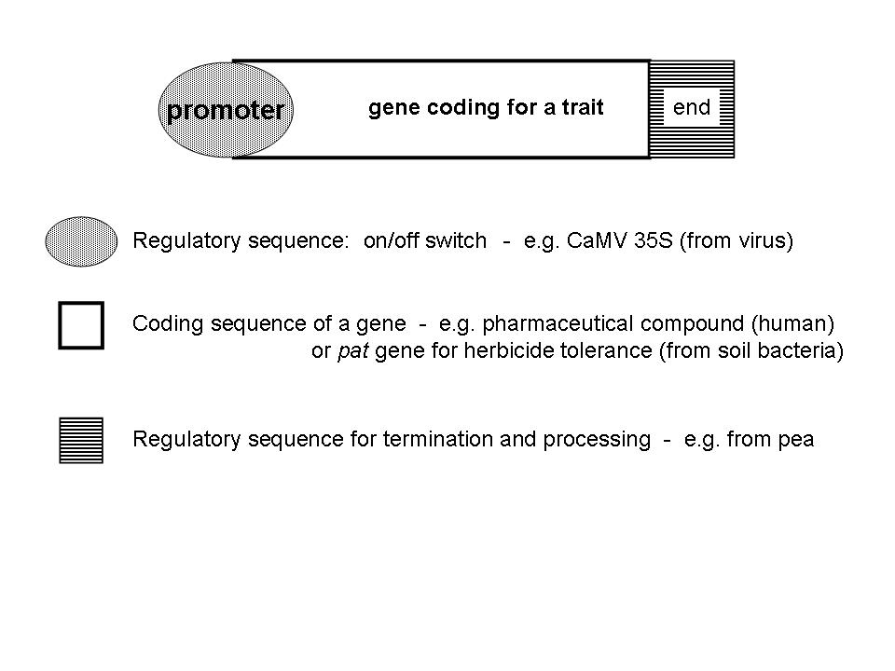
Figure 1: Gene Construct (transgene)
A gene is, in general, made up of a promoter, a coding sequence and a termination sequence (see text for details)

Table 1: Site specific recombination systems
Components: a) recombination enzyme, i.e. recombinase or invertase
b) small DNA recognition site

Recombination enzyme /  recognition site | Origin | Reference
Cre/loxP | bacteriophage P1 | Dale and Ow, 1990,1991; Odell et al. 1990
Flp/frt | Saccharomyces cerevisiae | Lyznik et al. 1993
R/RS | Zygosaccharomyces rouxii | Onouchi et al. 1991
Gin/gix | bacteriophage Mu | Maeser and Kahmann 1991

Table 2: Inducible Expression Systems using external inducers
Expression System or Inducer | Drawbacks
Bacterial repressor-operator systems

- Tetracyclin-inducible TetR | Leaky expression, high level of tetracycline required (short half-life, toxic to plants in high concentrations, not applicable to all plants)
- Tetracycline-inactivatable tTA | negative controlled system, constant tetracyclin required to shut off expression system, loss of promoter activity over time (methylation)
- Pristinamycin | not tested in whole plant
Fungi derived systems
- Copper inducible ACEI | copper is an essential plant nutrient, phyto-toxic in high concentrations. Not suitable for field application.
- Ethanol inducible AlcR | photo-toxicity negligible. Low basal activity, induction rapid and reversible. Inducer highly volatile. Risk: inappropriately triggered by endogenously produced ethanol (due to anoxia)
Steroid receptor based systems
- Glucocorticoid (vertebrate origin)  - Dexamethasone-inducible GR fusions | inducible by glucocorticoid or dexamethosone. DM sometimes causes growth defects & activation of defense related genes. Not suitable for field application.
- Estrogen/estradiol inducible XVE | high efficiency and specificity. Might not work in species with phyto-steroids, e.g. soybean.  Not suitable for field application.
- Ecdysone agonist | high expression levels, but relatively high background expression. Inducer tebufonizide used as insecticide (against lepidopteran pests).
Plant origin
- Safener-inducible in2-2 | Inducer is an agrochemical. Causes growth abnormalities. Promoter inducible by other chemicals. High base level expression in roots.

References:
Gatz C and Lenk I (1998). Promoters that respond to chemical inducers. Trends in Plant Science, Vol 3, Iss 9, pp 352-358
Wang RH; Zhou XF; Wang XZ (2003). Chemically regulated expression systems and their applications in transgenic plants. Transgenic Research, Vol 12, Iss 5, pp 529-540
Pallidam M (2003). Chemically regulated gene expression in plants. Current Opinion in Plant Biology 6:169-177

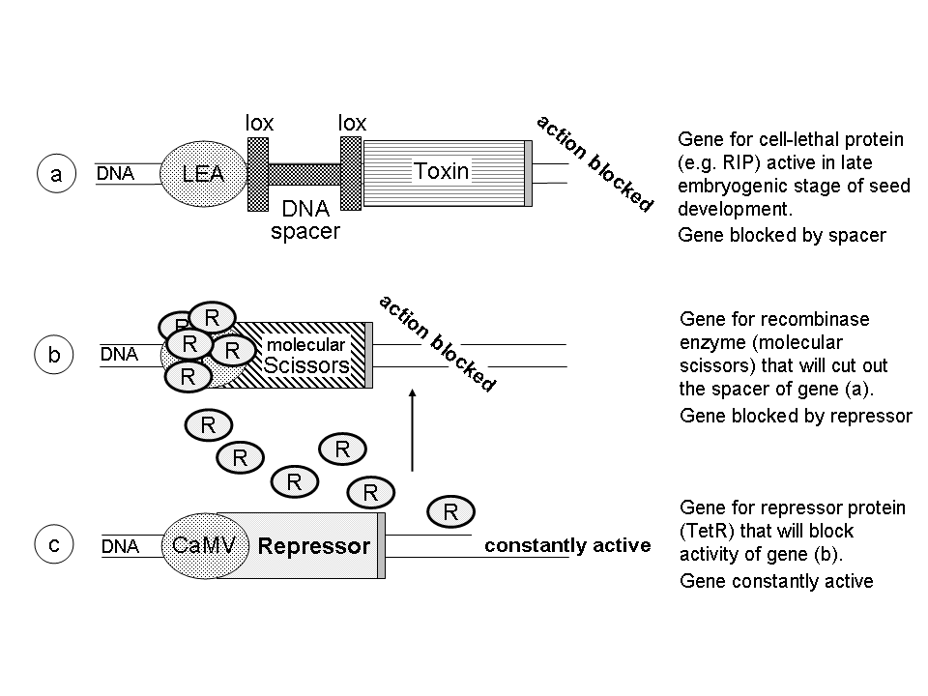
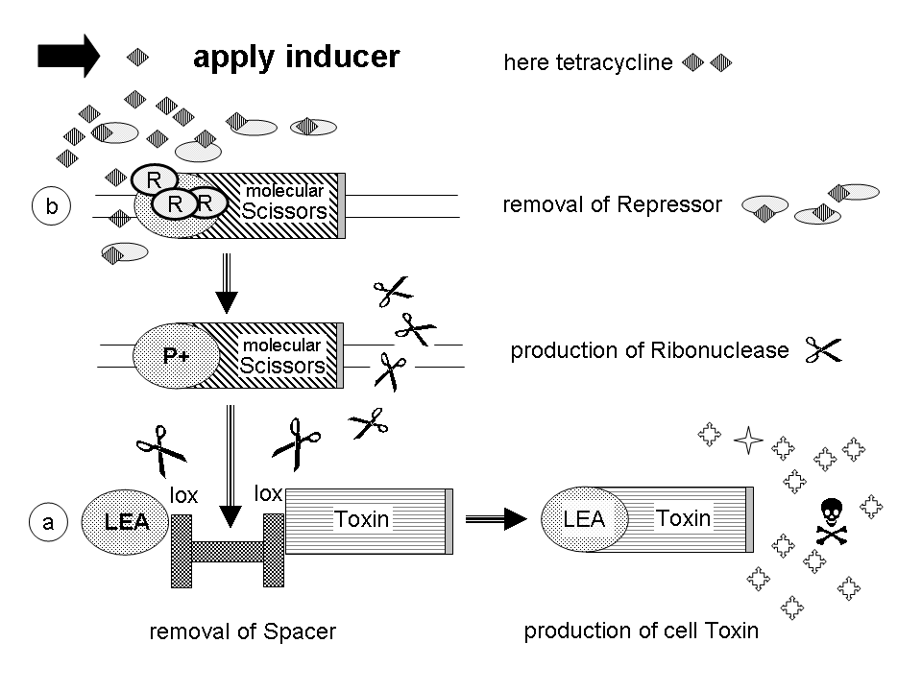
Figure 2: V-GURTs Design.
The V-GURTs design depicted is modelled on the Delta & Pine Land design (see text for details). The trait for seed sterility is blocked in the upper panel, showing the interaction of the 3 gene-constructs and their products involved. The lower panel illustrates the activation of the terminator mechanism, starting with the application of an inducer.

* UNEP/CBD/WG8J/4/1.
The CaMV 35S promoter is derived from the Cauliflower Mosaic Virus. It has been found to be constantly active in almost all parts of a plant. A gene placed behind this promoter will thus constantly express (produce) the protein it is coding for.
e.g. saporin from Saponaria officinalis or barnase from Bacillus amyloliquefacien
The main four site-specific recombination systems presently researched for various purposes are: Cre/loxP, Flp/frt, R/RS and Gin/gix (see Table 2).
The 35S promoter in the DPL design contains three tet operator sequences in the same location as that described by Gatz et. al. (1992)
Point mutation refers to alterations of the genetic code as small as one nucleotide, that is one “letter” in the coding system inscribed in the DNA molecule.
Some plants are well adapted to oxygen depletion, capable of using ethanolic fermentation of carbohydrates for energy production, resulting in ethanol and CO2 production. Rice or rice grains, for example, survive submergence for a long period of time, and were found to produce ethanol during the whole period. Barley and wheat (grains) on the other hand are less well adapted and are found to produce ethanol only on the first days of submergence (Guglielminetti et al., 2001).

